**Coursera Capstone**

**IBM Applied Data Science Capstone**

**Opening a New Pizza Shop in Bangalore, Karnataka**

**By: Varun Behera**

**October 2019**

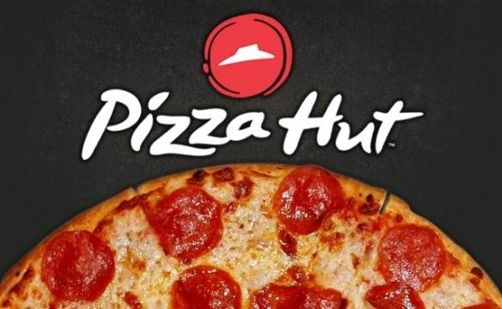

**INTRODUCTION**

Today’s Youngsters in India are most fascinating to living the lifestyle of the people of the west and also their food style is changing the same direction. Nowadays **pizza** an Italian originating food item is wide spreading in various parts of India. Not only young people but people of every age group are also preferring to eat pizza as snacks in the IT city of India.

As the taste for pizza is increasing day by day and more percentage of population in this city are leaning their taste in having such food in every hour of the day. Home delivery is also available in many outlets but the northern and southern regions of Bangalore take the whole charge. Thus, there is scarcity of pizza outlets in other regions of the places of Bangalore.

As a result, there are many pizza outlets in the city of Bangalore and many more are being built. Opening pizza shops allows food investors to earn consistent income. Of course, as with any business decision, opening a new pizza outlet requires serious consideration and is a lot more complicated than it seems. Particularly, the location of the pizza shop is one of the most important decisions that will determine whether the pizza shop will be a success or a failure.

**BUSINESS PROBLEM**

The objective of this capstone project is to analyze and select the best locations in the **city of Bangalore, Karnataka** to open a new **pizza shop**. Using data science methodology and machine learning techniques like clustering, this project aims to provide solutions to answer the business question: In the city of Bangalore, Karnataka, if a **Pizza franchise** is looking to open a new pizza outlet, where would you recommend that they open it?

**TARGET AUDIENCE OF THIS PROJECT**

The project is particularly useful to the **pizza franchise or pizza brands** who want to open their new outlet in different parts of the city to cover the major sections of the city. By opening new outlets, they can also minimize the hustle and late deliveries, thus increasing efficiency and customer satisfaction.

Also, this project targeted to the **new entrepreneurs** who want to try their luck in the food word as this will give an ample amount of information of where to open an outlet in order to drag people towards themselves and complete with the big sharks with new offers and customer-oriented techniques.